**CROP PRODUCTION IN INDIA**

A PROJECT REPORT

***Submitted By:***

Sabyasachi Rath (230720100101)

Jyoti Ranjan Jena (230720100080)

Snehashree Mohapatra (230720100082)

Biswajit Swain (230720100113)

Abhishek Mohapatra (230720100106)

***In partial fulfilment for the award of the degree of***

**MASTER IN COMPUTER APPLICATION**



**ACADEMIC YEAR: *2023-2025***

# SCHOOL OF Engineering and Technology

**CENTURION UNIVERSITY OF TECHNOLOGY AND MANAGEMENT**

**BHUBANESWAR, ODISHA**

**1**

**CROP PRODUCTION IN INDIA**

A PROJECT REPORT

***Submitted By:***

Biswajit Swain (230720100113)

***In partial fulfilment for the award of the degree of***

**MASTER IN COMPUTER APPLICATION**



**ACADEMIC YEAR: *2023-2025***

# SCHOOL OF Engineering and Technology

**CENTURION UNIVERSITY OF TECHNOLOGY AND MANAGEMENT**

**BHUBANESWAR, ODISHA**

2

## BONAFIDE CERTIFICATE

Certified that this project report **“CROP PRODUCTION IN INDIA”** is the bonafide work of **“Biswajit Swain”** who carried out the project work under my supervision. This is to further certify to the best of my knowledge that this project has not been carried out earlier in this institute and the University.

**Signature of the supervisor**

**Prof. Subham Sahoo**

**(Asst. Prof., Dept. of MCA)**

*Certified that the above mentioned project has been duly carried out as per the norm of the college statutes of the university*

**SIGNATURE**

**(Professor & HOD)**

**DEPT. OF MCA, CUTM**

3

**ACKNOWLEDGEMENT**

It is our pleasure to be indebted to various people, who directly or indirectly contributed in the development of this work and who influenced my thinking, behavior and acts during the course of study.

I am thankful to, **Asst. Prof. SUBHAM SAHOO, Dept. of MCA** for his support, cooperation, and motivation, valuable presence that helped me in completing this project.

I also extend my sincere appreciation to **Prof. Rakesh Kumar Ray**, **HOD, Dept. of MCA** who provided her valuable suggestions and precious time in accomplishing my project.

***Name: Biswajit Swain***

***Regd. No:230720100113***

4

**ABSTRACT**

Agriculture is an important sector in India. It is indispensible for the sustenance and

growth of the Indian economy. On an average, about 70% of the households and 10% of the

urban population is dependent on agriculture as their source of livelihood. Today, India is a

major supplier of several agricultural commodities like tea, coffee, rice, spices, oil meals, fresh

fruits, fresh vegetables, meat and its preparations and marine products to the international

market. India is a large producer of several agricultural products. In terms of quantity of

production, India is the top producer in the world in milk, and second largest in wheat and rice.

Agricultural production is prone to several risks which affect both producers and consumers. In

order to enhance investment and achieve a sustained increase in production, coherent and

integrated long-term strategies and policies are required to reduce risk aversion and build

flexibility among Indian rural producers. There is a need to provide remunerative prices for

farmers in order to increase the incomes of farmers. In this research paper researcher’s objective

is to study the major agriculture crops production, export and import of agriculture crop wheat. A

researcher also does there analytical study of this major agriculture crop Wheat.

Agriculture is an important sector in India. It is indispensable for the sustenance and growth of the Indian economy. On an average, about 70% of the households and 10% of the urban population is dependent on agriculture as their source of livelihood. Today, India is a major supplier of several agricultural commodities like tea, coffee, rice, spices, oil meals, fresh fruits, fresh vegetables, meat and its preparations and marine products to the international market. India is a large producer of several agricultural products. In terms of quantity of production, India is the top producer in the world in milk, and second largest in wheat and rice. Agricultural production is prone to several risks which affect both producers and consumers. In order to enhance investment and achieve a sustained increase in production, coherent and integrated long-term strategies and policies are required to reduce risk aversion and build flexibility among Indian rural producers. There is a need to provide remunerative prices for farmers in order to increase the incomes of farmers. In this research paper researcher’s objective is to study the major agriculture crops production, export and import of agriculture crop wheat. A researcher also does their analytical study of this major agriculture crop Wheat.

5

## TABLE OF CONTENTS

|  |  |  |
| --- | --- | --- |
| **SL NO.** | **SUBJECT** | **PAGE NO.** |
| 01 | Introduction | 07 |
| 02 | Plan Of Implementation | 07 |
| 03 | Objective of the program | 08 |
| 04 | Approach and Design | 08-09 |
| 05 | Data Visualization | 10 |
| 06 | Implementation | 10-20 |
| 07 | Data Cleaning | 11 |
| 08 | Conclusion | 20 |

6

## Introduction :-

Machine Learning is a branch of Artificial Intelligence that aims at solving real-life engineering problems. This technique requires no programming, whereas it depends on only data learning where the machine learns from pre-existing data and predicts the result accordingly. Machine Learning methods have benefit of using decision trees, heuristic learning, knowledge acquisition, and mathematical models. It thus provides controllability, observability, stability and effectiveness.

India’s production of food grains has been increasing every year, and india is among the top producersOf several crops such as wheat, rice, pulses, sugarcane, and cotton. It is the higher producer of milkand second highest producer of fruits and vegetable.

### Plan of Implementation :-

The project can be broken down into 7 main steps which are as follows:

1. Understand the dataset.
2. Clean the data.
3. Analyse the candidate columns to be Features.
4. Process the features as required by the model/algorithm.
5. Train the model/algorithm on training data.
6. Test the model/algorithm on testing data.
7. Tune the model/algorithm for higher accuracy.

### Problem Statement :-

  The scope of this project is to mainly proposing a business problem and finding the possible solution. So, here is the proposal for which I’ve worked for the entire project- ‘**To provide the necessary information visualization, I'll analyze the crop production data’s of India in different region and map them using Geocoder and Folium library.**

7

### Objective of the Project:-

The main objective of this project is to mainly proposing a business problem and finding the possible solution. So here is the proposal for which we have worked for the entire project- to provide the necessary information visualization, we will analyse the crop production data’s of India in different region.

**APPROACH AND DESIGN :-**

The below figure explains the approach we have taken into building the predictive model using machine learning algorithms.

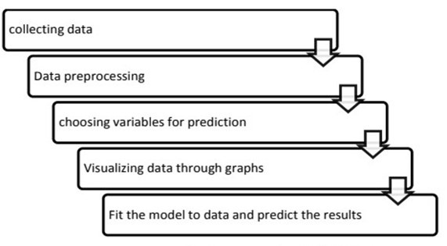

**Fig.1 predicting crop production**

8

### Data Collection:-

Data collection is the process of gathering and measuring information from countless different sources. In order to use the data, we collect to develop practical machine learning solutions.

Collecting data allows you to capture a record of past events so that we can use data analysis to find recurring patterns. From those patterns, you build predictive models using machine learning algorithms that look for trends and predict future changes.

### Data Pre-processing:-

#### Data cleaning

There are some null values in the dataset in the columns such as winner, city, venue etc. Due to the presence of these null values, the classification cannot be done accurately. So, we tried to replace the null values in different columns with dummy values.

#### Choosing Required Attributes

This step is the main part where we can eliminate some columns of the dataset that are not useful. This is estimated using feature importance. The considered attributes have the following feature importance.

9

### Data Visualization

* The data which has been collected is used for visualizing for the better understanding of the information.

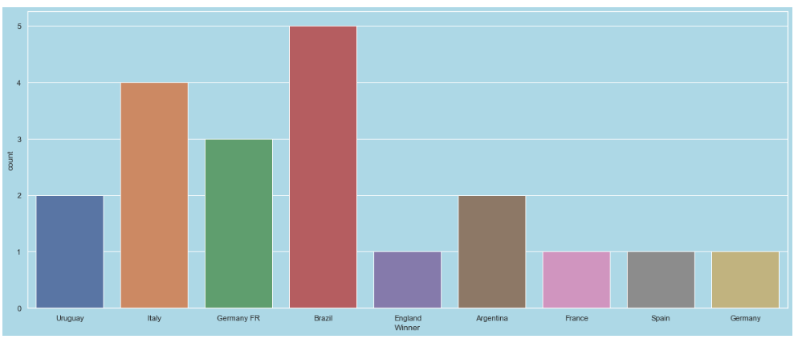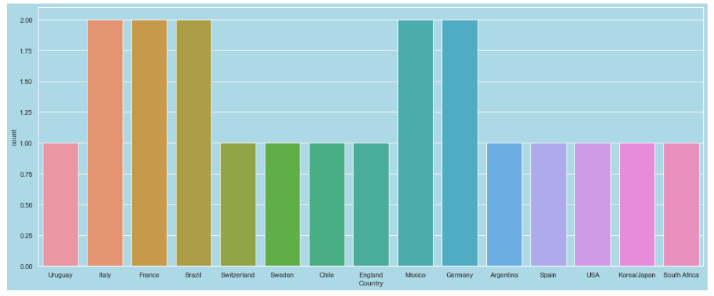

* Matplotlib Library is used here for visualizing the graphs
* The data visualization is necessary to understand the solution in a better way.

### Model Development and Evaluation

Here, we have developed a generic model and applied all classification methods. The data is split into training data and test data, we train the model using certain features and use it to predict the testing data, then we calculate the performance of the system. The various classification models used are: Logistic Regression, Gaussian Naïve Bayes Classifier, KNN (K Nearest Neighbour) algorithm, Support Vector Machines, Gradient Boost Algorithm, Decision Trees and Random Forest Classifier. Among these methods the Random Forest and Decision tree has given good results.

**10**

**IMPLEMENTATION**

**IMPORTING LIBRARIES:-**

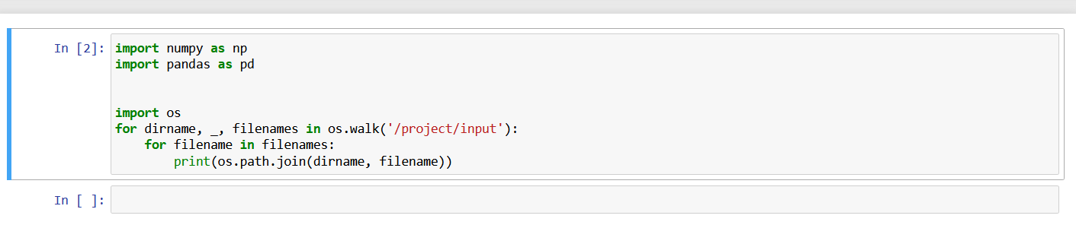

**IMPORTANTDATASET:-**

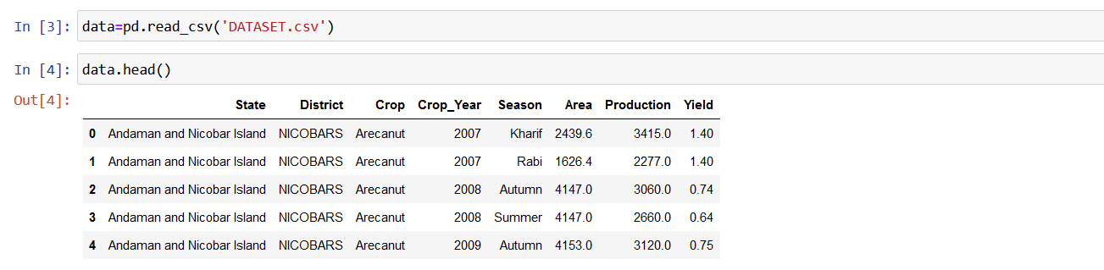

**COLUMNS:-**

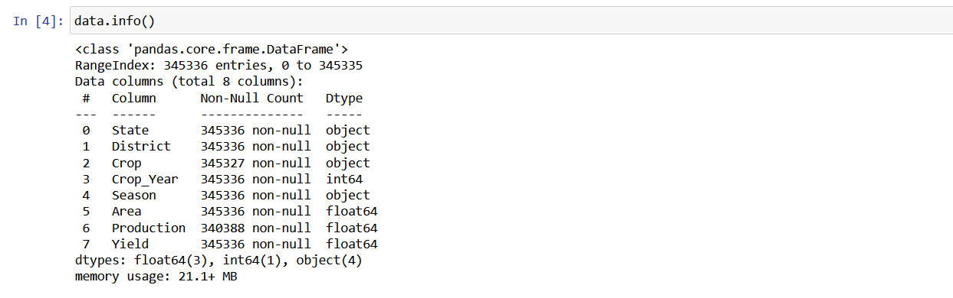

11

**DETERMINEDATASET:-** 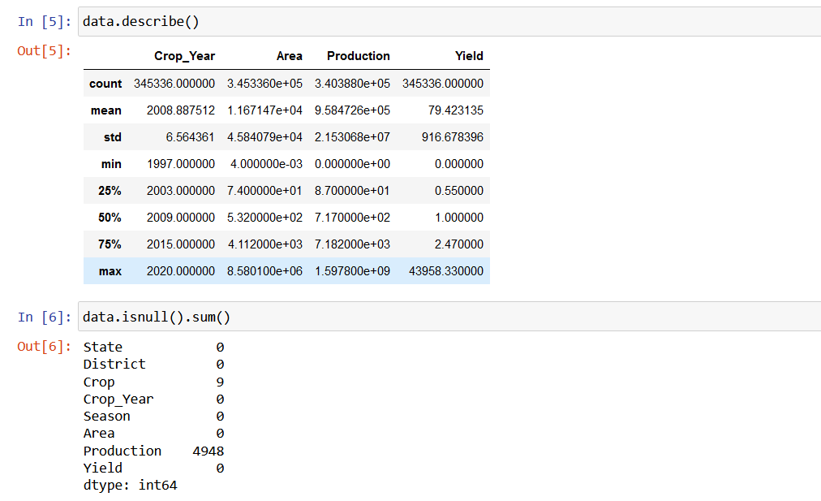

**CLEAN DATASET:-**

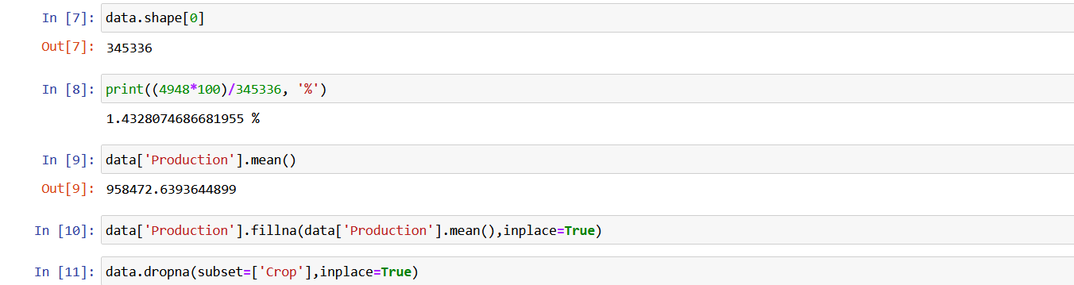

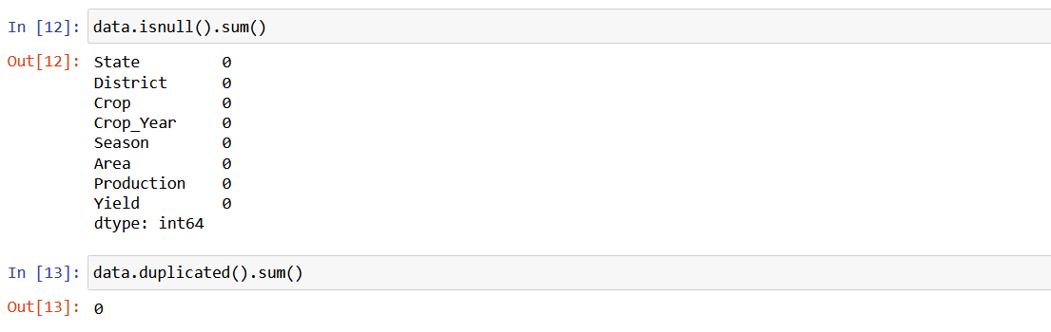

12

**DETERMINING FEATURES OF THE DATABASE:-**

## STATE WISE DATA OF PRODUCTION:-

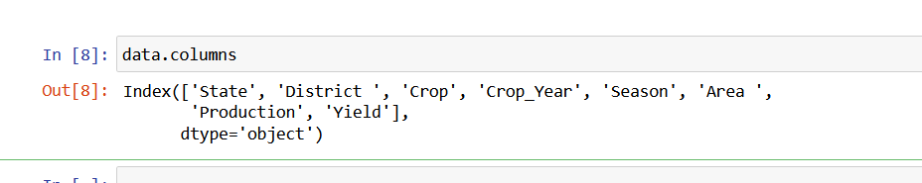

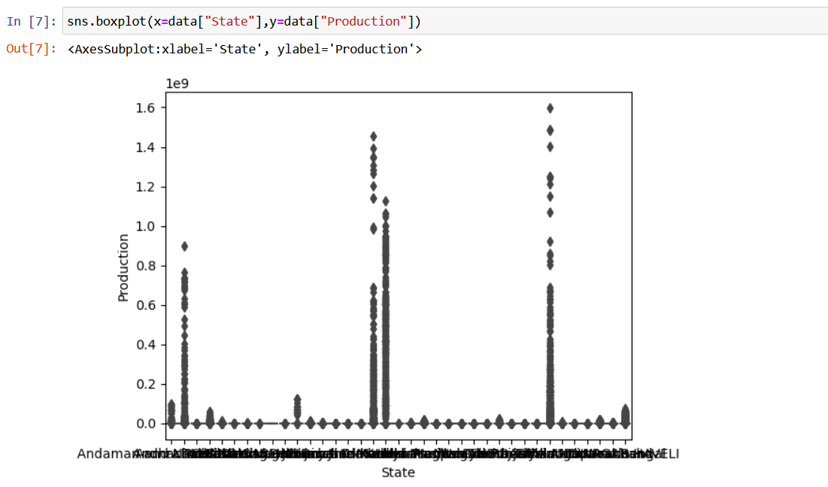

13

## DISTRICT WISE DATA OF PRODUCTION:-

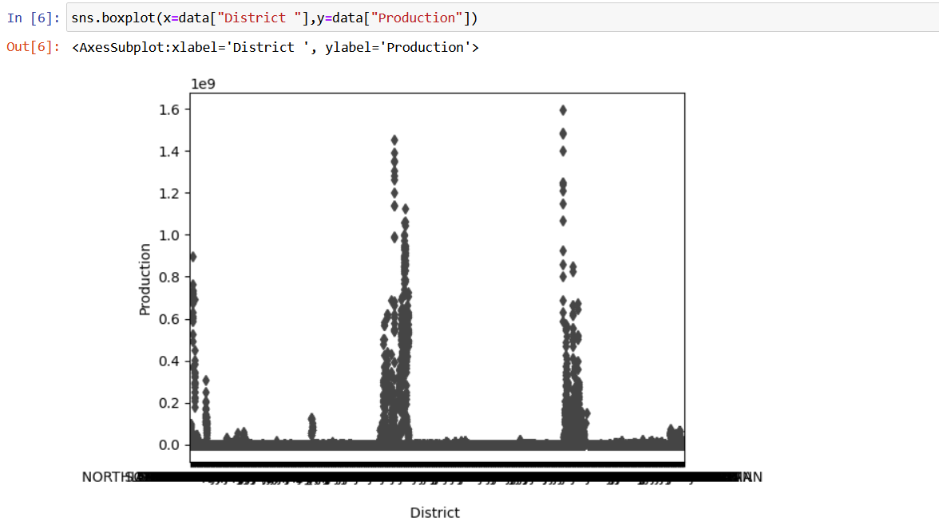

## YEAR WISE CROP PRODUCTION IN INDIA:-

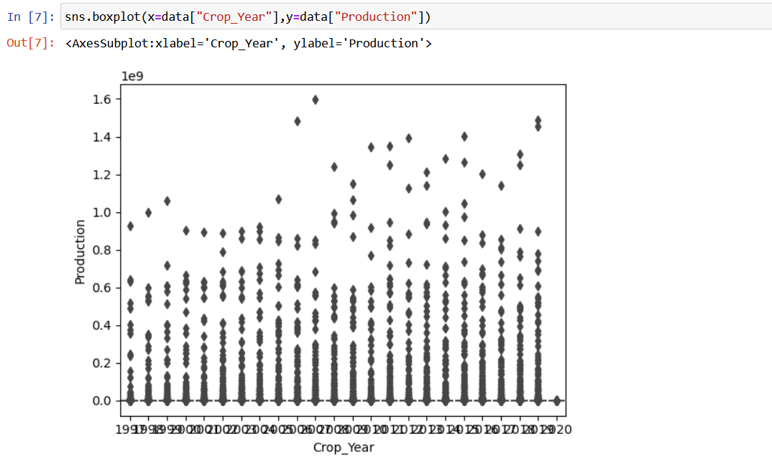

14

## SEASON WISE CROP PRODUCTION:-

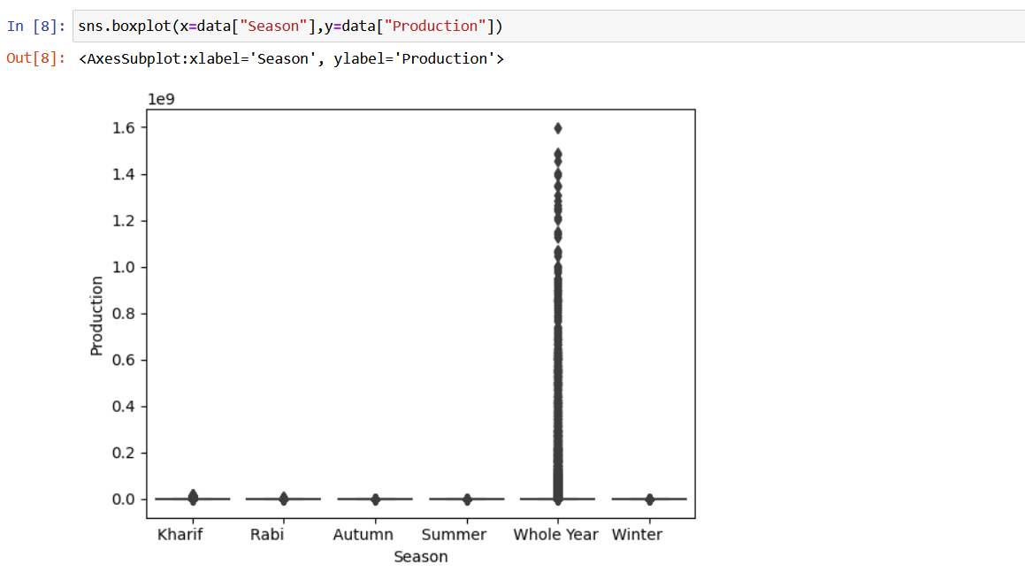

## GRAPHICAL REPRESENTION :-

EAR WISE GRAPHICAL REPRESENTATION:-

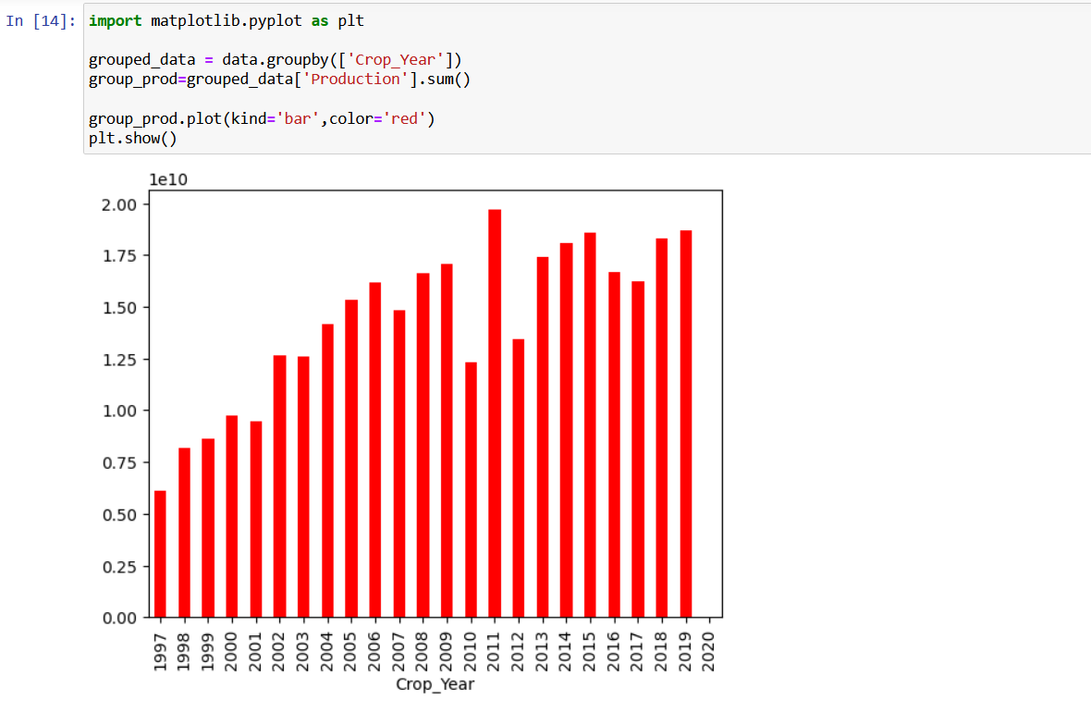

15

## STATE WISE GRAPHICAL REPRESENTATION:-

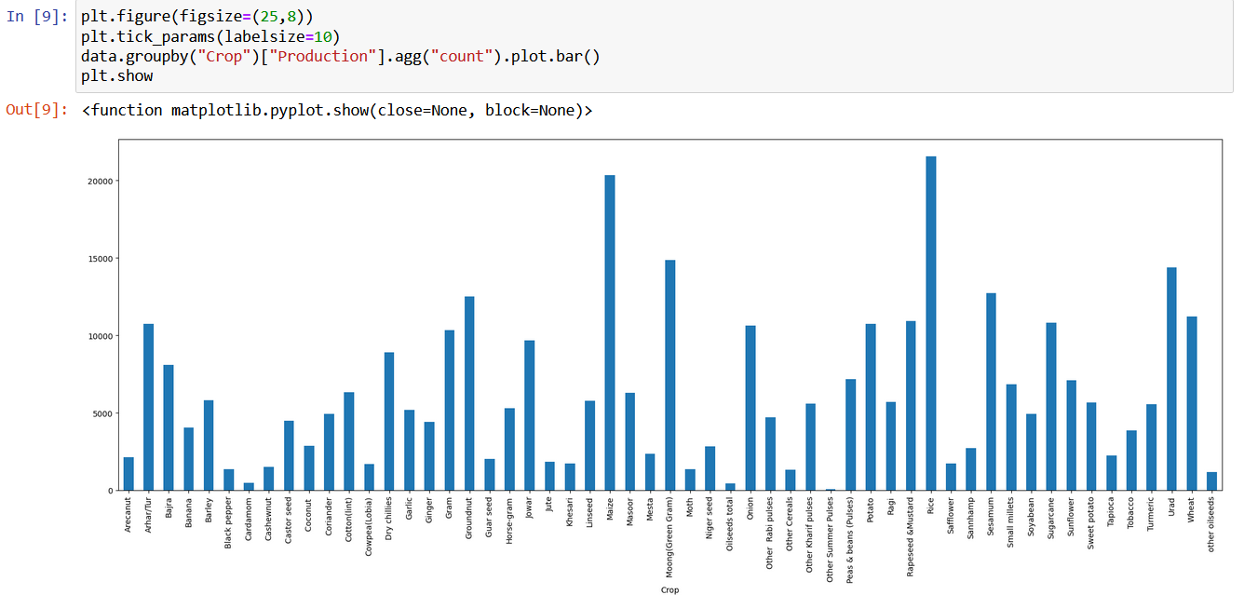

## STATE WISE PRODUCTION IN PLOT DIAGRAM:-

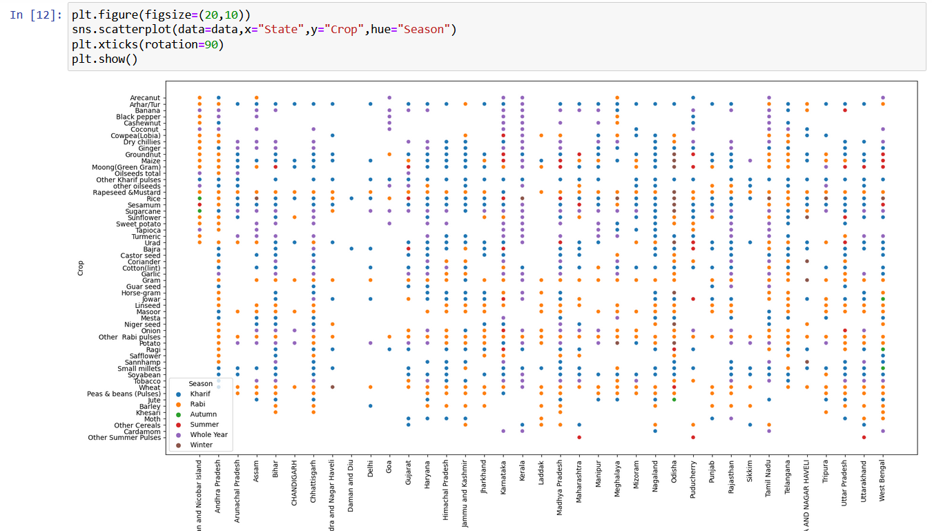

16

## CROP PERCENTAGE USING PIE CHART:-

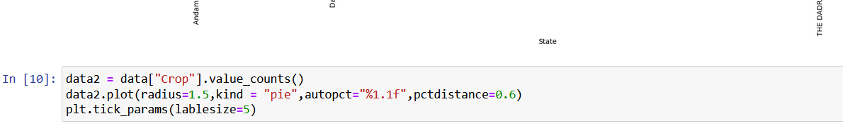

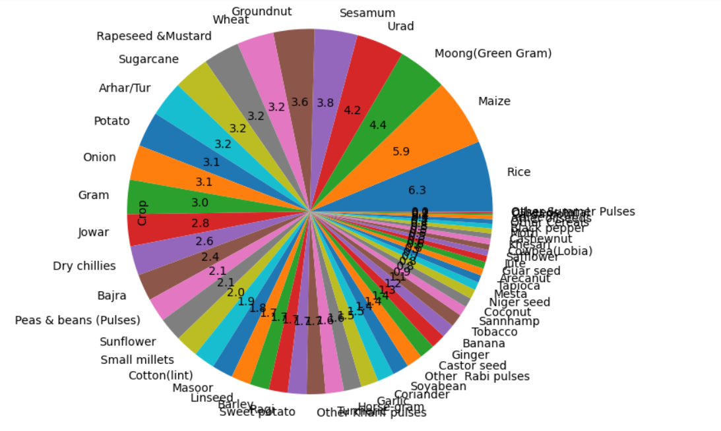

17

## STATE WISE CROP PRODUCTION USING BAR DIAGRAM:-

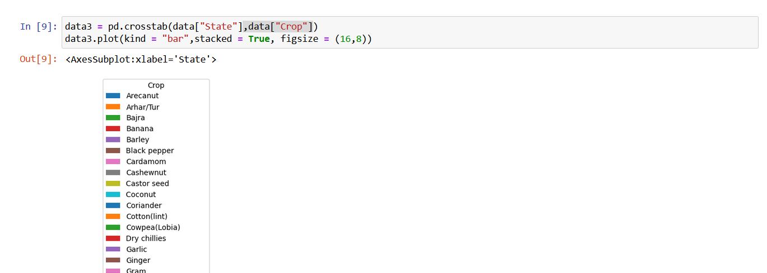

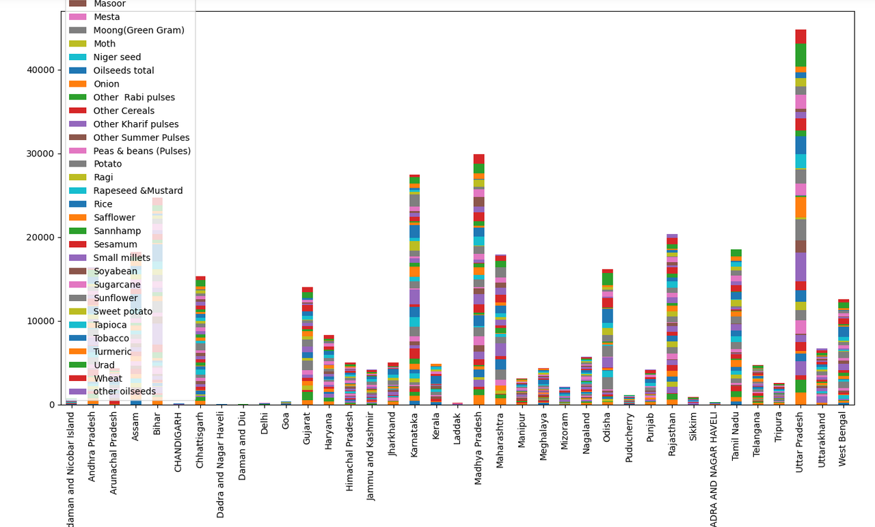

## TOTAL NUMBER OF DISTRICTS:-

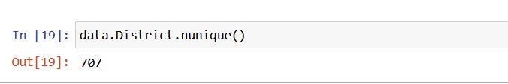

18

**SEASONS AND PRODUCTION:-**

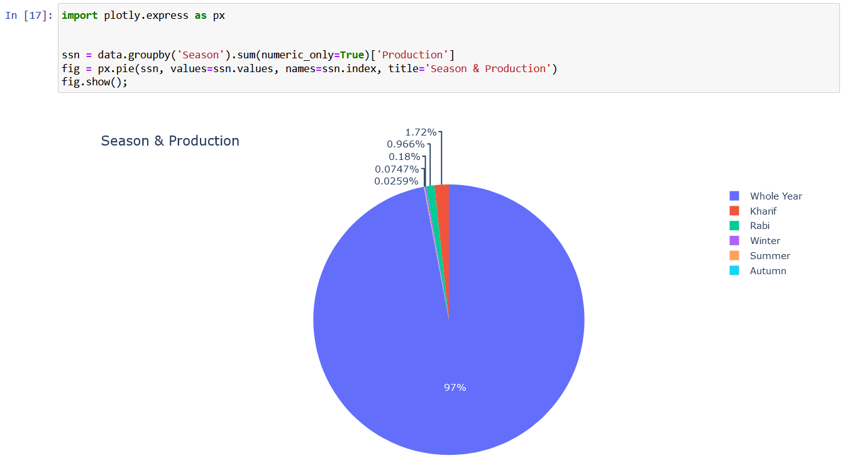

**TOP 10 CROPS PRODUCED:-**

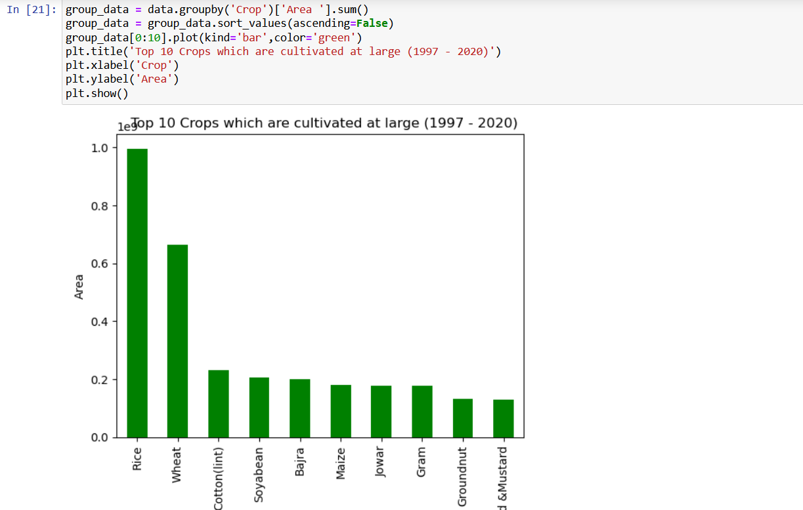

19

**TOP 10 STATES WITH HIGHEST YIELD:-**

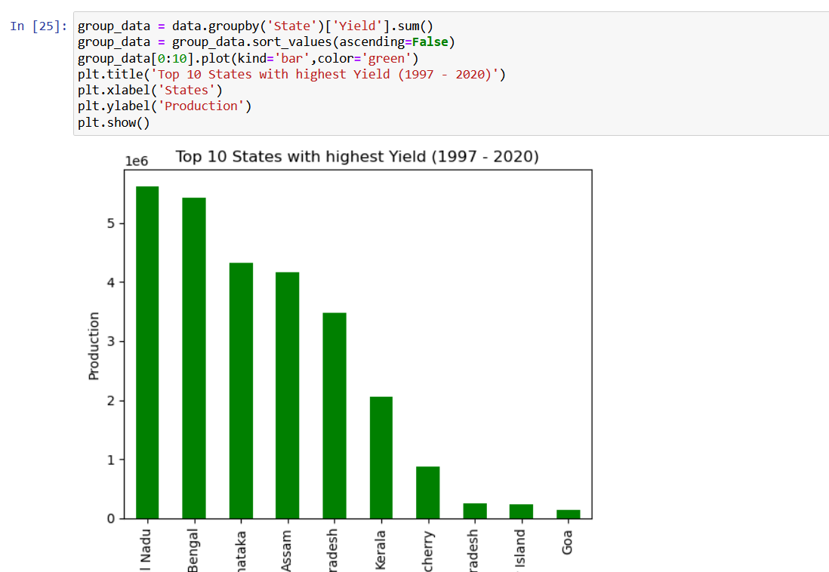

**TOP 10 STATES WITH HIGHEST PRODUCTION:-**

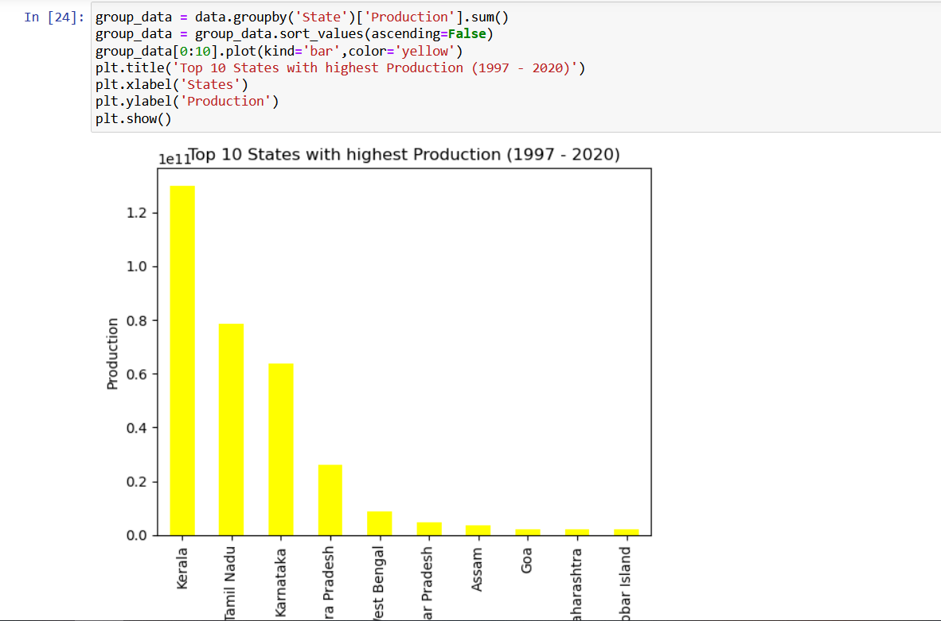

20

## CONCLUSION

One of the best advantage of this project is that you can easily interact with the data directly and observe the trends of as many product and region as you wish. So, as discussed earlier this can play a major role for choosing the sight and cost estimation for your business. Although as far I analysed is not sufficient enough for a big business, but a slight extension with this project can make it a perfect efficiency booster of your business in this field.

**...........*****...........**

21

**REFERENCES**

* [**https://www.kaggle.com/**](https://www.kaggle.com/)
* [**https://www.analyticsvidhya.com/blog/2021/10/introduction-to-matplotlib-using-python-for-beginners/**](https://www.analyticsvidhya.com/blog/2021/10/introduction-to-matplotlib-using-python-for-beginners/)
* [**https://www.plot.ai/**](https://www.plot.ai/)
* [**https://www.geeksforgeeks.org/data-visualization-with-python/**](https://www.geeksforgeeks.org/data-visualization-with-python/)

**...........*****...........**

22